20140628 I2C Tutorial

Original Document: [Jeremy's Original Video Tutorial](http://www.jeremyblum.com/2011/02/13/arduino-tutorial-7-i2c-and-processing/)

Other Reference Material: [I2C vs SPI](http://www.byteparadigm.com/applications/introduction-to-i2c-and-spi-protocols/)[According to Pete - SPI and I2C (use wit tylenol)](https://www.sparkfun.com/news/980)

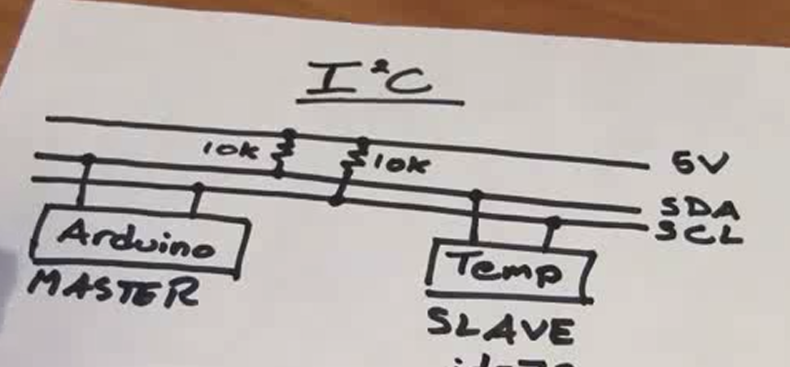

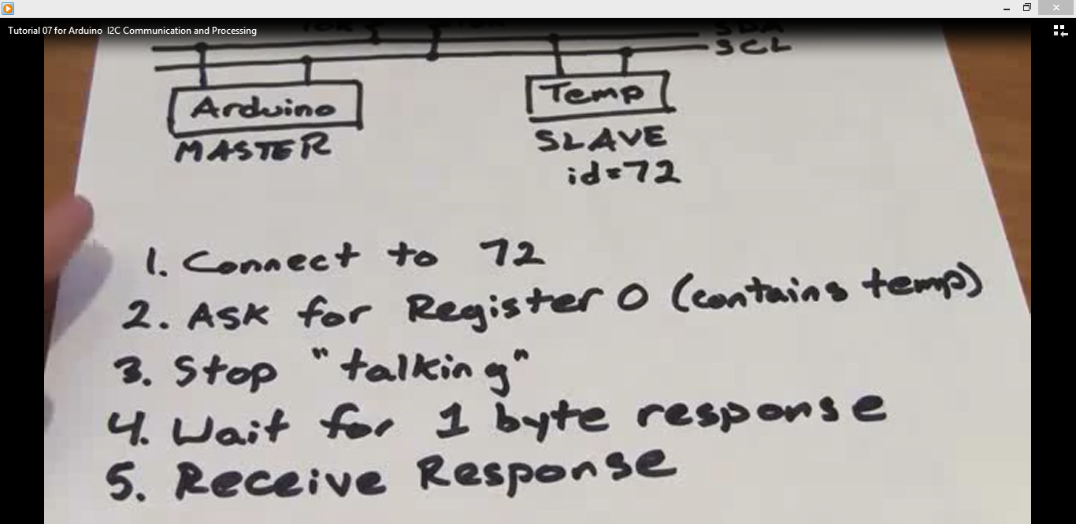

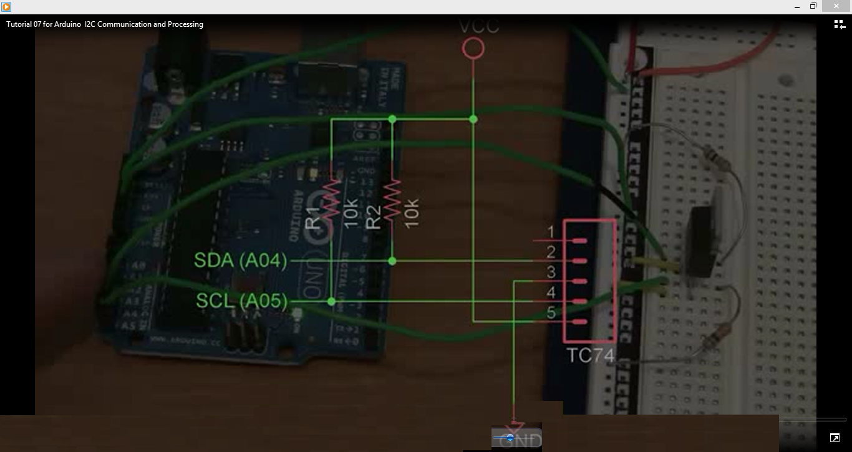

-----------------------------------------------------------------------------------

CODE (This is the first test code). There is more code including as PC display for info.

//Program by Jeremy Blum

//www.jeremyblum.com

//Reads Temp in Celcius and Shows it on Computer

Include Wire I2C Library

#include <Wire.h>

int temp_address = 72;

void setup()

{

//Create Serial Object (9600 Baud)

Serial.begin(9600);

//Create a Wire Object

Wire.begin();

}

void loop()

{

//Send Request

Wire.beginTransmission(temp_address); //Start talking

Wire.send(0); //Ask for Register zero

Wire.endTransmission(); //Complete Transmission

Wire.requestFrom(temp_address, 1); //Request 1 Byte

while(Wire.available() == 0); //wait for response

int c = Wire.receive(); // Get the temp

//do some math...

int f = round(c*9.0/5.0 +32.0);

Serial.print(c);

Serial.print("C,");

Serial.print(f);

Serial.print("F.");

delay(500);

}